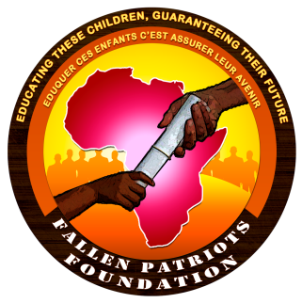
Fallen Patriots Foundation
Eduquer ces Enfants, C’est assurer leur Avenir
Educating these Children, Guaranteeing their Future
(F.P.F.)
Authorization No. 00001467/ARDA/J06/ALPAS/APPBA

Ref:..................LE/F.P.F./2016

Dear well-wishers,

Subject: Letter of introduction and Appeal

It is an honour for the Fallen Patriots Foundation (F.P.F.) to present this letter of introduction and appeal for your support of its activities.

Addressing this correspondence today is the President and Coordinator of the Foundation, by name Ndiwane Laura epse SAKO, a proud Sakerrette and graduate of the 1994 batch.

The Fallen Patriots Foundation is a charity, non-political, non-denominational and non-profit making organisation focused on assisting children of soldiers fallen in the course of defending our nation. Since the declaration of war against Boko Haram, about 125 Cameroonians soldiers have been killed leaving behind more than 450 children without a parent and full parental support. Considering the above situation and acknowledging the government support to these children, the FPF, is working to;

- Provide educational assistance to children of soldiers, from all branches of the military fallen in the line of duty;
- Provide counselling and psychosocial assistance to the affected children/families to enable them accept their loss;
- Provide assistance in the compilation of the necessary documentations required for the obtainment of benefits due them by the state;
- Act as a central clearing house and facilitator between these children/families concerned and potential benefactors;
- Provide sustainable support to these children to enable them achieve their dreams.

The foundation is propelled by the slogan ‘Educating these children, guaranteeing their future’.

In view of our upcoming scholarship grants award ceremony scheduled for Maroua, Garoua and Yaounde respectively on the 10^{th,}, 12th and on the 19th of August 2016, the Fallen Patriots Foundation will be honoured, with your generosity and goodwill gesture which will go a long way to help ensure a future of education to these children, whose parents have given in everything for our Nation.

Herewith, are copies of the report on the launching of its activities, a write up on its history and objectives and a video projection

Your prompt response will go a long way to put a smile on the faces of these children.

Accept dear well-wishers, the assurances of my highest consideration and thanks in advance for supporting our cause.

