He passed away December 23rd 2003 in Maryland. I had gone to Maryland with him December 15th to visit my sisters and my Mom who was also there. While in Maryland he became extremely ill and we had to rush him to Washington Hospital center, from shortness of breath. He was intubated and was in the hospital for two days and then passed on the early morning of December 23rd.May his Gentle Soul Rest In Perfect Peace with Our Lord. He was a Good man and a Great Dad. I will in my own words call him a Saint, not just because he is my Father but from what I have heard from a lot of people whose lives he had touched. To this day, I still get people who would tell me that my father was the one that gave them OVALTINE pens and pencils for school. Everywhere my dad went he was surrounded by kids because they knew they would get either an OVALTINE cap, a pencil, a ruler or a pen .I remember how he made it a point to go to the maternity ward at the Bota hospital to deliver BEBELAC to pregnant mothers or to new born babies. My father cherished doing good to people. He was the Sole Importer of OVALTINE, BEBELAC and BIRD’S CUSTARD in Cameroon. He was known as Pa MENEMO or Pa OVALTINE by some people. I could go on and on about my Dad without end because it's like a never ending story. To this day the people in our village in Metta are still feeling his absence because he was always sending things like salt, flour & OVALLTINE every Christmas season to all in the village.
My Dear, this is life and we have to just give God the Glory. Again I thank you for what you are doing. You will be blessed.
Olivia.

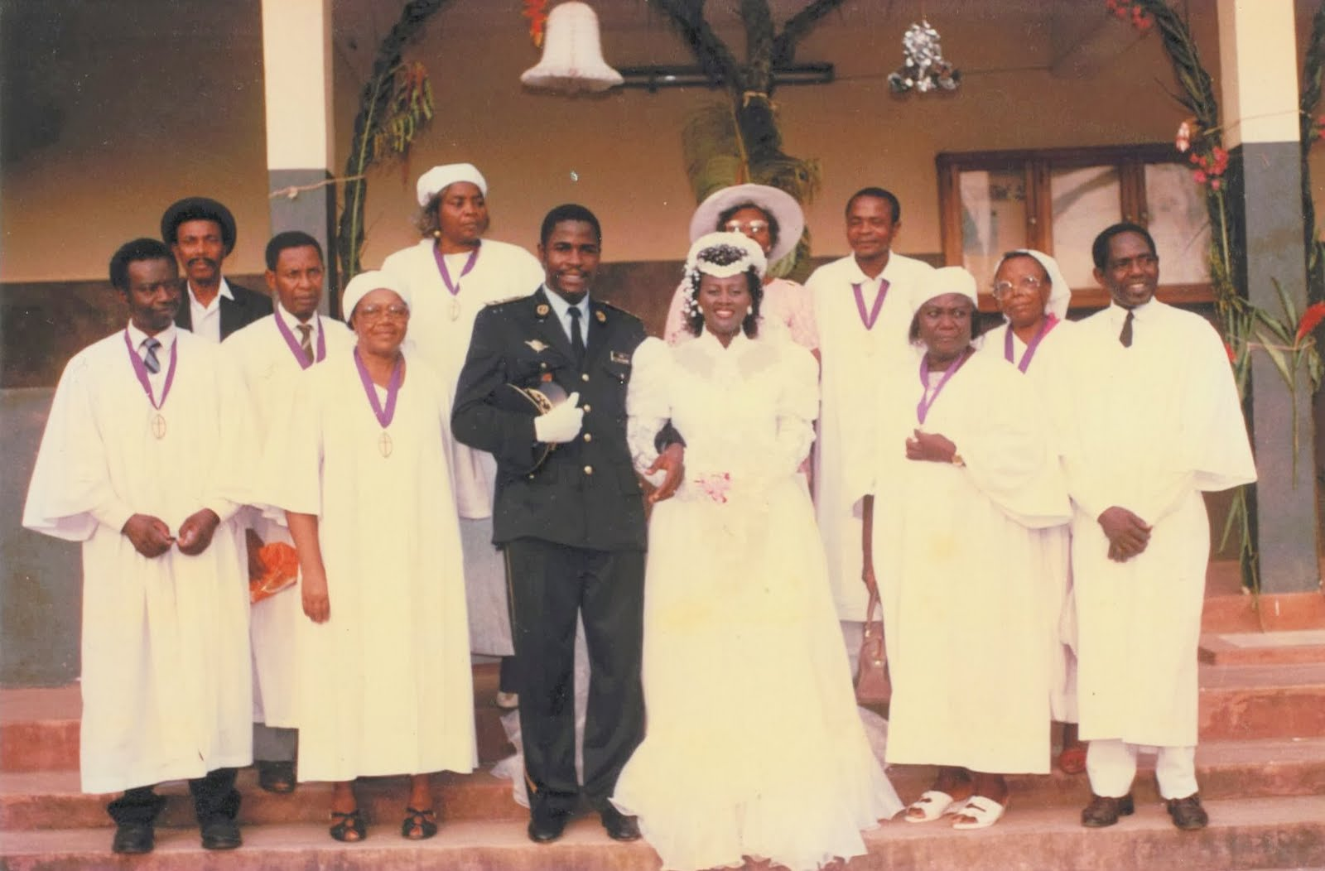
(Picture from SakerPride personal collection shows Mr. D.F. Nguh – Front Row, 1st from the left, with his fellow Down Beach Presbyterian Church Elders on January 12th 1991)

